Computer Science 301

Web Technologies

Practical 1: Week beginning 5 October 2020 [60 Marks]

Part I: Identifying technologies for developing a web application [10]
- Identify technologies that are used for Web Applications and put them into the correct space within the web request-response loop and associated entities (browser, web server, computing back engine etc). For each technology, give a brief description (which should NOT be copied from another place) and explaining where they are generated (possibly) and consumed within the loop. Start with HTML and the more the merrier! ;-).
A table will be sufficient, but if you like to be more sophisticated you can put the technologies in a diagram which represents the loop and the various entities.

They can explain it in any way – need to talk about the HTTP communication (5 point) and what the browser will do when it gets the response (5 point). One possible picture is the following.
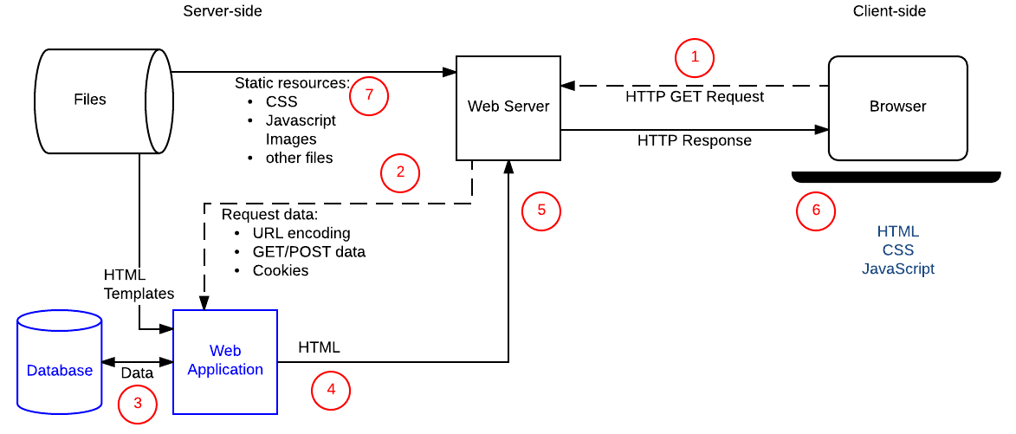

Part II: Using Browser Developer Tools [20]
- a) Open a new tab in your browser. Then open the Network panel from Developers tools window (for Chrome browser) of your browser to answer the following questions. You can also use Firefox (. Pls follow the following steps as described here:
- Type “up.ac.za” (without the double quote – by the way this is supposed to be the website of the University of Pretoria) in the address bar and hit enter. Does the page open? What error message do you get?
The page doesn’t open. The connection has timed out. [2]
- Now add the “www.” prefix to the above url to make it www.up.ac.za and hit enter. Does the browser get a 200 OK response for this request? If not, why didn’t it get the same response when you send the above request? [5]
No. It gets a 302 response.
To understand why it didn’t get this response in the above case, students need to utilize their networking knowledge. If they try to ping or use traceroute they can see that there is DNS record for above address (137.215.10.220), but the server may be down or not web server running there. The new server runs on 104.17.191.191 and looks like it is bound to a content distribution network (CDN). You can check this by pinging to the two addresses. Normally we use the www prefixed url as CNAME record in the DNS record, but this is not the case here. CDNs do not support top-level domains (also called naked domain). In general, this question relates to DNS records and they should somehow mention this to earn a mark.
- Remember, we tried to open other pages like cnn.com without www and didn’t get an error. What is the reason that UP’s website not working like this? Looks like the answer could be similar
- How many interactions did your browser made before it loads the page? It should be many (more than 80) depending on when they record the interaction.
More than 80 – sometimes the browser may cache some responses and we may have less interactions (because it ignores cached content). [5]
- What are those interactions? Loading the different resources (fonts, css pages, scripts etc). [5]
- Refresh the page using the reload button and see if the same thing happens? (I mean you still get the error). I said this because, we still see “up.ac.za” in the address bar but the browser gets a 200 OK response right after it sends the GET command. Why is that? You can even check this by closing this tab and opening another tab and entering “up.ac.za” and see what happens. Discuss what is going on? [5]
Browser gets information about the url without the www prefix from the first response to the above request (when we include the www prefix), in the response header we have the following header:
access-control-allow-origin: https://www.up.ac.za/ https://up.ac.za http://www.up.ac.za https://www.up.ac.za and it caches this – they should mention this or at least mention about cache
- Give any character encoding that you see in the url.
No encoding at this point.

Part III: Using appropriate HTML tags [15+15=30]
I have attached the solution files together with this email.
- a) The resources for this question are all found in the “Question3a resource files” folder. [5 mark for each question]
Open prac1-3a.html in the editor of your choice, and start making the following changes so that you will get a page like the one below the questions:
- Start by adding a link to Related Photos, in the unordered list that currently contains Descriptions and Reviews. (You can make the href attribute point to # for the moment.)
- Now go down to the bottom of the page and add the new Related Photos <section>.
- In the new section add three images from the ones provided in the images folder. Use the small images related-square1.jpg, related-square2.jpg, and related-square3.jpg in the src of your <img> tag, but link to the large images with almost the same names. I also want you to put the images by creating a folder named images under your html file and refer the images as such by using the appropriate path.

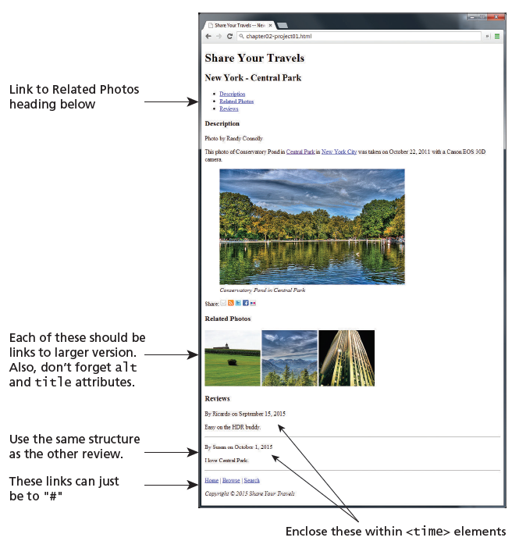

b) The resources for this question are also found in the “Question3a resource files” folder.
Open prac1-3b.html in the editor of your choice, and start making the following changes so that you will get a page like the one below the questions:
- Reflect on why adding semantic markup is a worthwhile endeavor, even if the final, rendered page looks identical. [7]
- Replace and supplement generic HTML tags like <div> with semantic tags like <article>, <nav>, or <footer> (for example). Some parts make sense to wrap inside a tag such as <section> or <figure>. [8]

